RMB Navigation- Finance Project and Sales Contract – C0527

|  |  |  |  |  |
| --- | --- | --- | --- | --- |
| **Ver** | **Date** | **Author** | **Comments** | **Reviewed by** |
| 1 | 08/02/2020 | Tom Bell | CRIM 0528 | TBC |
|  |  |  |  |  |

Requirements 2

Prerequisites 2

Solution Overview 2

Solution Details 2

Security 3

Companies 3

Data Migration 3

Test Steps 3

Technical Implementation 3

Requirements

An RMB option called “Sales Contract” from the (Financials>Project Accounting>) Project screen, in Finance Project header. This RMB must take the user to (Contract Management > Sales Contract) Sales Contract screen and must display the Sales Contract with the same ID as the Finance Project.

An RMB option called “Financial Project” from the (Contract Management > Sales Contract) Sales Contract screen, in the Sales Contract header. This RMB must navigate to the (Financials>Project Accounting>) Project screen, displaying the Finance Project with the same ID as the Sales Contract.

Prerequisites

<Describe any pre-requisites that this development may rely upon, data configuration or other developments>

Solution Overview

# Sales Contract RMB (from Project screen)

An RMB option called “Sales Contract” from the (Financials>Project Accounting>) Project screen, in Finance Project header. This RMB must take the user to (Contract Management > Sales Contract) Sales Contract screen and must display the Sales Contract with the same ID as the Finance Project.

RMB Name

* “Sales Contract”

# Financial Project RMB (from Sales Contract screen)

An RMB option called “Financial Project” from the (Contract Management > Sales Contract) Sales Contract screen, in the Sales Contract header. This RMB must navigate to the (Financials>Project Accounting>) Project screen, displaying the Finance Project with the same ID as the Sales Contract.

RMB Name

* “Financial Project”

Solution Details

# RMB from Sales Contract screen to Project screen

The below screenshot shows where the RMB option “Financial Project” must be available from in red.

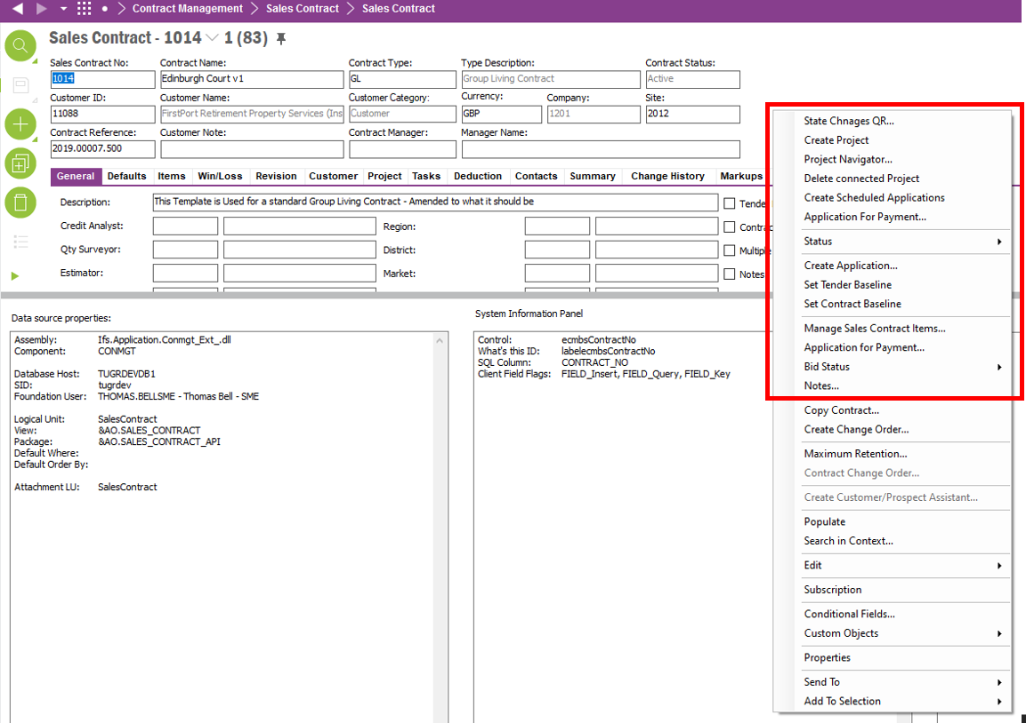

The below screenshot shows the Financials>Project Accounting> Finance Project screen. This is the screen that must be navigated to when the RMB is selected. Depending on the Sales Contract ID header that is RMB’d will determine which Finance Project is opened (see in red the Project ID).

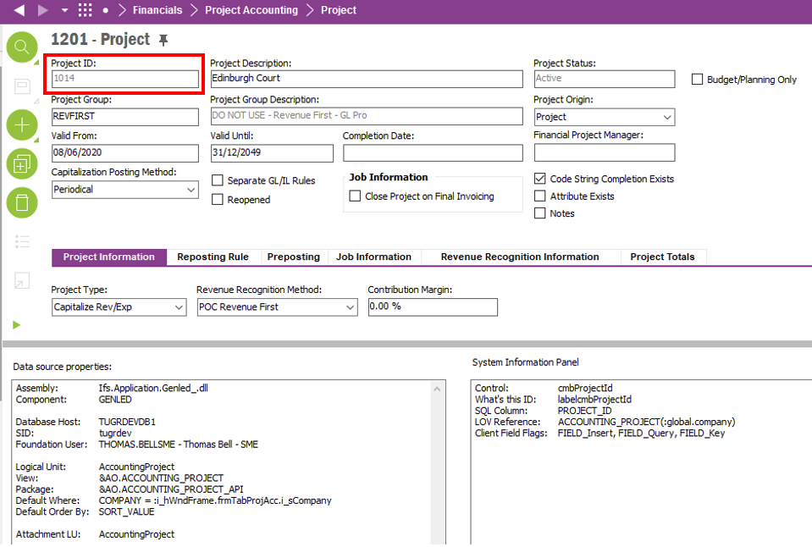

# RMB from Project screen to Sales Contract screen

The below screenshot shows where the RMB option “Sales Contract” must be available from in red.

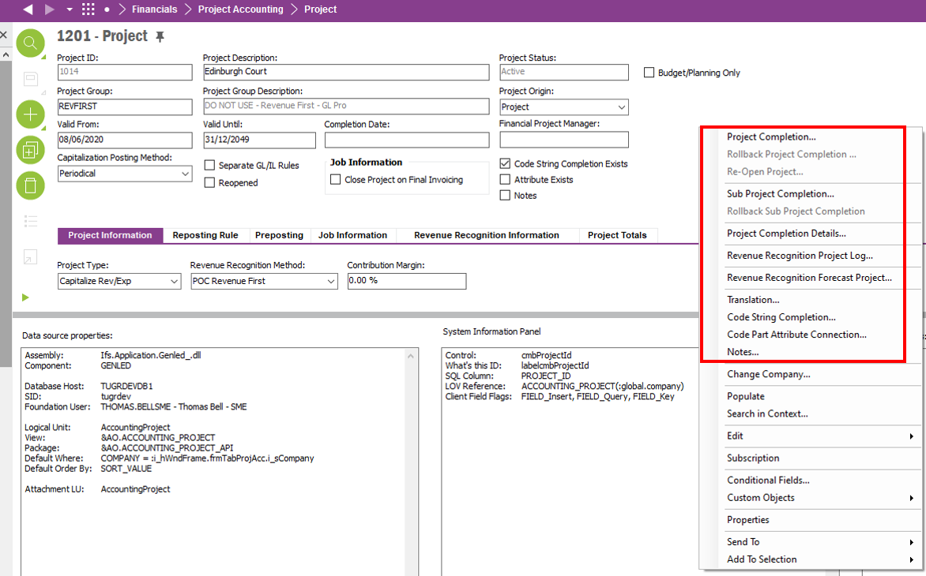

The below screenshot shows the Financials>Project Accounting> Finance Project screen. This is the screen that must be navigated to when the RMB is selected. Depending on the Sales Contract ID header that is RMB’d will determine which Finance Project is opened (see in red the Project ID).

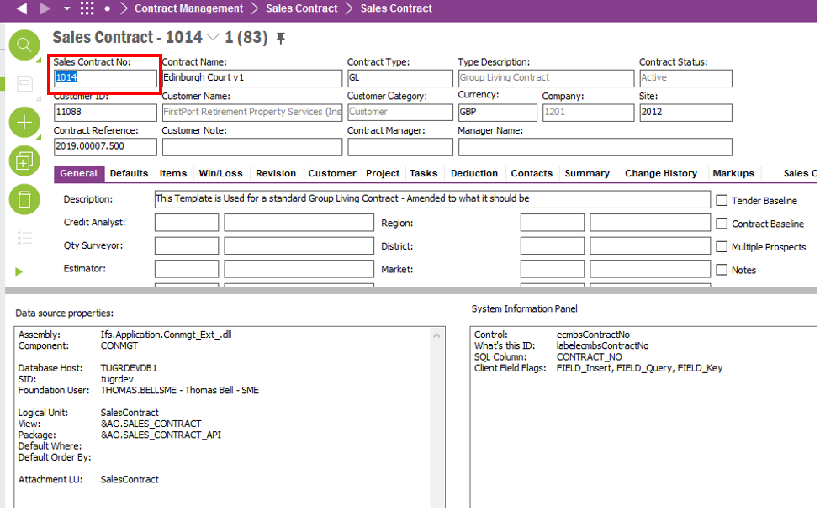

**Technical.**

Field Definitions.

<New Field/CLU Definition>

|  |  |  |  |  |  |  |
| --- | --- | --- | --- | --- | --- | --- |
| New DB Object Name | DB Object Item/Field Names | Item Description | Item Data Type | Item Syntax | Calculation Spec, if Derived | LOVs/Enums/Is Mandatory? |
|  |  |  |  |  |  |  |
|  |  |  |  |  |  |  |
|  |  |  |  |  |  |  |
|  |  |  |  |  |  |  |
|  |  |  |  |  |  |  |
|  |  |  |  |  |  |  |
|  |  |  |  |  |  |  |
|  |  |  |  |  |  |  |
|  |  |  |  |  |  |  |
|  |  |  |  |  |  |  |
|  |  |  |  |  |  |  |
|  |  |  |  |  |  |  |

Security

<Define security controls> (Who needs access to this and will it be restricted from any other users etc)

Companies

Applies to the following companies. All.

|  |  |
| --- | --- |
| **Company** | **Required (Y/N)** |
| 1201 | Y |
| TBC |  |
|  |  |

Data Migration

<Describe any data migration impacts this development may have – i.e additional data to be migrated>

Test Steps

<Steps that needs to be taken to test this change. Please provide expected results> Updated post solution.

|  |  |  |
| --- | --- | --- |
| **No** | **Script\Test Steps** | **Expected Result** |
| 1 | In the(Financials>Project Accounting>) Project screen when RMB-ing in the header | Must see the RMB option “Sales Contract”. |
| 2 | Clicking the “Sales Contract” RMB. | Must navigate the user to (Contract Management > Sales Contract) Sales Contract screen and must display the Sales Contract with the same ID as the Finance Project |
|  | In the (Contract Management > Sales Contract) Sales Contract when RMB-ing in the header | Must see the RMB option “Finance Project”. |
|  | Clicking the “Sales Contract” RMB. | Must navigate the user to (Financials>Project Accounting>) Project screen and must display the Finance Project with the same ID as the Sales Contract. |

Technical Implementation

<Completed by the technical developer - Technical solution, list packages, functions, Custom menus created etc >

**Package**

EA_FINANCE

**Permission Granted**

IFS_ALL

**Custom Menus (RMBs)**

Project Window

Sales Contract Window

